p1- What will the output be when the following code is executed?

name, phone, location = "Robert", 123455667, "Dar es salaam"

print(name, phone, location)

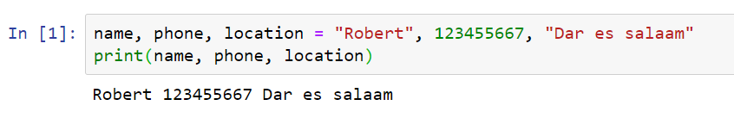

2- What will be the output when the following code is executed?

area = 25.6

area = int(area)

print(area)

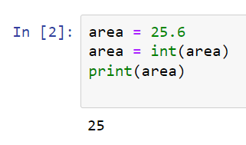

3- What will be the output when the following code is executed?

val1 = int(input())

print(len(val1))

Answer: Type Error

4- What does the following code do:

print( 1 ** 4 // 2).. Answer: 0

5- What will the output be after executing the following code snippet?

print(9** 3 ** 0 ** 1) … Answer : 9

**Name:** ____________________ **Roll – No:** ______________



**Q1: Write only answers for following:**

**Q2: Write answer with explanation (how you reach the answer):**

1- What will be the output when the following code is executed?

print(end="\n\n\n",sep=":") Answer: Three blank lines

2- What would be the output of the following code:

print(2 % 5 ** 2) Answer: 2

3- What will be the output when the following code is executed?

val1 = 0b111

val2 = val1 << 2

print(bin(val2))

Answer: 0b11100

4- What will be the output of the following print statements?

lst1 = [2,4,6]

lst2 = [2,4,6]

print(lst1 is lst2)

print(lst1 == lst2)

Answer: False True

5- What will be the output of the following print statement?

str = "Hello Python!"

str = str[-7:len(str)]

print(str)

Answer: Python!

6- What will be the output of the following print statement?

tupl1 = (1., 2., 3.)

tupl2 = ("Earth", "Mars", "Jupiter")

x = (tupl1 + tupl2)[-3]

print(x)

Answer: Earth

7- What is the result of the following print statement?

capitals1 = ["London","New York","Rome"]

capitals2 = capitals1

capitals2.remove("New York")

print(capitals1)

Answer: ['London', 'Rome']

8- What will be the output of the following code when executed?

cities = {"UK":"London","France":"Paris","Germany":"Berlin"}

for city in cities.items():

print(city)

Answer:

('UK', 'London')

('France', 'Paris')

('Germany', 'Berlin')

9- What will be the output of the following code when executed?

for i in range(1, 3):

print(i)

else:

print("hi")

Answer:

1

2

hi

10- What is the result of the following code when executed?

def fun(x = 4, y = 5):

y -= 1

return x * y * 1

print(fun())

Answer: 16